Chapter 6, Solution 37.

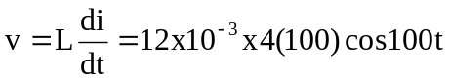
= 4.8 cos (100t) V

p = vi = 4.8 x 4 sin 100t cos 100t = 9.6 sin 200t

w = 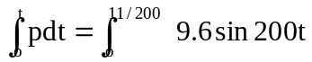
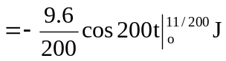
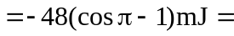 96 mJ

Please note that this problem could have also been done by using (½)Li².

